**SUNYANI TECHNICAL UNIVERSITY**



**FACULTY OF APPLIED SCIENCE**

**DEPARTMENT OF COMPUTER SCIENCE AND INFORMATION COMMUNICATION TECHNOLOGY**

# PROJECT WORK IN PARTIAL FULFILMENT OF OUR CERTIFICATE IN A

**HIGHER NATIONAL DIPLOMA IN INFORMATION AND COMMUNICATION TECHNOLOGY**

**CASE STUDY: SUNYANI TECHNICAL UNIVERSITY**

**PROJECT TOPIC:**

**DESIGN AND IMPLEMENTATION OF AN EMPLOYEE LEAVE MANAGEMENT**

**SYSTEM.**

**TABLE OF CONTENT**

Table of Contents

**ABSTRACT1**

**CHAPTER ONE: INTRODUCTION2**

1.4 BACKGROUND OF STUDY4

1.5 PROBLEM STATEMENT5

1.6 OBJECTIVE OF STUDY6

1.6 SIGNIFICANCE OF STUDY6

1.7 LIMITATIONS OF STUDY7

**CHAPTER TWO: LITERATURE REVIEW8**

2.1 INTRODUCTION8

2.2 RELATED WORK9

###### 2.2.1 Employee Information Management System 9

2.2.2 Computerize ELMS 9

2.2.3 Staff Management System10

2.2.4 System Scheduling Activities 10

2.2.5 Proposed System10

2.3 SUMMARY 11

ABSTRACT

Leave management systems to combine several processes and systems to automate and easily manage employee data, leave requests, track and grant leave. In many institutions staff is entitled to different types of leave, these leave are granted according to institution policy. The administrative department is mostly responsible for managing and granting leave requests. To this end, most institutions used conventional methods of requesting, granting, and managing leave. In the conventional method, leave is manually requested by writing a letter to the head of the department. The head of department minutes and forwards the request to higher staff for approval. This method is time-consuming, prone to error, requires more paperwork, and is difficult to manage. Hence the need for an automated leave management system that is faster, error-free, less paperwork, and easy to manage. The system will be achieved by developing an automated employee leave management system using the three-tier software architectural model.

The System will be implemented using web-based technologies which include CSS, JS, HTML, MySQL, PHP and runs on Windows operating system. Over the years, paper-based system for information management has been carried out across most of business and organizational sectors. Overcoming this problem is the main focus of this project in order to reduce the risk of redundancy. This thesis describes the design and implementation of a system that will have the capability for storing related information about employees through database. The system serves as a bridge between the database and the users that helps in maintaining and retrieving records, it also focuses on the number of leaves taken by employee per year with the help of full-edged computer software and computerized tools, so that personal data can be stored for future reference. The required system is amiable to users and easy to work with without any redundant entries. After implementation of the objective modules, all functions were tested and successful.

CHAPTER ONE

# 1.0 INTRODUCTION

An employee leave management system is a platform that enables staff and administrator of an organization or institution to easily apply, correctly allocate, track and grant leave (Chugh 2014), staff is entitled to a different kind of leave; study leave, sick leave, annual leave, leave without pay, research leave and maternity leave. These leave are been taken and recorded according to institution policy. The administrative department is mostly considered as one of the most important assets in every institution. It is a part of the administrative department’s function to keep all the records of employees. Every institution’s administrative department is information-driven, and the administrator staff drives and carries out day-to-day activities. In most institutions, the conventional method of requesting and managing leave is been used. In the conventional method, academic staff is required to manually write and submit leave applications to the administrative department through the Head of Department (HOD). The head of department minutes and forwards the request to higher staff in charge, who approve or reject the request. This method is time-consuming, prone to error, required more paperwork and is tedious to maintain. Hence the need for an automated method that is faster, error-free, with no paperwork, and easy to manage. Employee leave management is a web-based application that and management of an institution. It makes it easy for an employee to request and track their leave.

The administrative department of an institution on the other hand can easily allocate, grant, and manage all leave requests. The employee leave management system automatically reflects the request to the relevant superior officer for approval. If the superior officers reject the leave, a reason for rejecting the leave must be entered into the system and the employee who requested the leave will be notified if the leave request requires a higher superior officer for approval before notifying the employee, the respective officer will be notified. The system will also notify other members of staff that are required to know. This will enable the administrative department to administer leave or notes to the next applicant, to track and manage the employee leave. For every leave requested by an employee, the system will automatically deduct the applicant leave from total leave and notify all parties involved the total leave is taken, the remaining balance, and when next the leave will be taken according to a policy of an institution. Several literatures exists in leave management ; Hridita, et al., (2018) documents an internship report on the leave management system but due to the time factors, the confidentiality of organizational data, and resources limitation, only a few details of the system were described. Mishal et al., (2017) developed an intranet-based leave accessed within an organization. The system can be used to request, approve, and generates reports of leave but only works on the intranet. Manish et al., (2015) developed a leave and payroll management system for requesting, viewing history, and granting/rejecting leave requests. Rushitha et al., (2019) develop a windows-based leave management system for effective and efficient management of staff leave requests and approval/rejection. Although the system can manage staff leaves efficiently, it can only work on the Windows operating system platform as such can be used as a web-based application. Isaac et al., (2018) developed prototyped a cloud-based employee management information system for Sunyani Technical University consisting of four modules; leave management, payroll management, staff appraisal, and record management. Though the system was designed to cover all aspects of human resources in Sunyani Technical university, only a prototype of the proposed system was developed at the time of carrying out this research.

1.1 BACKGROUND OF STUDY

In any organization, there is an existence of a system that manages its staff information effectively.

This brings the need to develop a database that stores and retrieves relevant information of staff. In the development of the leave management system, the storing of data of the organizational staff is prioritized. The database management which controls the creation and maintenance of records together with the leave and attendance management provides an efficient and flexible way to manage the organization’s personnel information. The combination of these modules into one application assures the perfect platform for aligning Human resources processes in the organization.

The Human Resources office in any organization contributes to the organizational mission of public service by facilitating informed decision-making regarding employee benefits by providing accurate, timely, accessible information. of the many benefits available to the employees, leave is one of the most valuable.

Leave management system is an electronic online stage that circles all sorts of leave applications and leaves regard, and the methodology to record numerous types of leaves (Nucleus, 2008). The interface is designed to reduce data redundancy and automate the leave application processes and their endorsements. It eliminates the paperwork process and spares time.

As an IT students, we were motivated to conduct research on this study and design a desktop application because of an encounter through experience during our interview an organization. I was motivated by this topic when I witness the process through which employees are given leave, even in a difficult situation. As I witness one of my supervisors applying for his leave and the vigorous process he went through and I saw the need for a change in this process, despite the health status of the employee seeking for the leave. Then as an IT companion, I had the thought of developing a system that will help to accomplish this task within the unit.

1.2 PROBLEM STATEMENT

Challenges are faced when handling employee records manually. This is evident in procedures such as leave management where an employee is required to fill in a form that may take several weeks or months to be approved. The use of paperwork in handling some of these processes could lead to human error. Another challenge is that most of the organizations have their employee leave records kept at the big file room in the administrative block of the organization making it difficult to access the employee leave information remotely when needed at short notice.

The above-identified problems can be resolved using the employee leave management system. The system will store and maintain employee records in a database management system with privacy only accessed by the administrator. The system will make it easy for the administrator to monitor the leave records of an employee.

**1.3 General Objective**: The main goal of the project is to design and implement an employee leave management system for Sunyani Technical University that will electronically handle the processes of the employee leave applications.

**1.4 Specific Objectives**

1. To develop a system that will enable the employees to check when they are due for leave.
2. To enable the employees to apply for leave and leave extensions online.
3. To create a module for an employee to check their leave status.
4. Send SMS notifications to employees on leave approval during and due date.

# 1.5 SIGNIFICANCE OF STUDY

The implementation of this employee leave management system that is linked to the organization’s requirements, offers access to records as well as services such as systematic leave management and schedule report generation which will make it easy for the organization to operate. The automated proposed system will upgrade the existing system and will be important to the users by eliminating the leave manual system process, the authorities in charge of the approval of leave requests will also not operate manually. Without the system, it is going to be a tiresome job for the employer to keep track of every employee’s leave process. The software will be developed to give access and provide information of employees and many other features with the click of a button, as we all know employees are the backbone of any organization and society.

# 1.6 LIMITATIONS OF STUDY

The data got for this study is restricted and confined to just staff records, organogram structure of the association.

The following will impinge on the efficiency of the system.

1. The system will fail if the server fails, but the data will remain stored in the database.
2. Where there is no web association, the system can't be utilized since it is online
3. The system is designed using PHP, MYSQL database, HTML, CSS Java script, bootstrap and some other libraries which as a result will only work on the web-based or a local server (For testing purposes).

**CHAPTER TWO:**

**LITERATURE REVIEW**

### **2.0 Introduction**

This chapter briefly describes the literature review relevant to the Employee Leave Management System (ELMS). It provides sufficient background knowledge based on relevant literature reviews of related works. The Employees Leave management system is designed to provide a computerize based process that is reliable and quick through the use of PHP computer programming language and MYSQL and database application. The chapter reviewed literatures that were relevant to the proposed project and identifies the gaps in the related systems that could be addressed by the proposed system.

The international organizations today are struggling to meet the unexpected business challenges. Organizations should be prepared to respond to the fast changing and highly competitive environment, maintaining standard and meeting stakeholder’s expectations (Muduli, 2015). In the last two decades organizations in effort to standing out in the crowd has focused mostly on human resource management practices especially with the rise of strategic human resource management approach (Zehra Alakoç Burma, 2014).

The success of any organization widely depends on Human Resources. Managing Human Resources strategically has become very important for the companies. In today’s world HR managers’ roles and skills have developed significantly because of the adoption and use of new technologies (JAIN, 2014).

In Human Resource Management, technology is an application of organizations using software and hardware to aid human activities. A couple of various parts for the innovation can be hiring and selecting employees for interviews, overseeing employee paperwork, and securing sensitive employee records. A wide range of kinds of equipment or programming are accessible for this reason. Organizations can either utilize an outer programming bundle or make their own, dependent on their requirements (Selvan, 2015).

A large organization manages a noteworthy volume of information of its employees. This action can be overwhelming without a more modern device to store and recover data. The different levels of advancement can be analyzed by taking an evolutionary aspects of HR innovation. These viewpoints can be described into four phases of improvement: Paper-based frameworks, early (PC) innovation, electronic databases, and Web-based (Simaanya, 2014).

People are one of the basic achievement elements of a business. Unapproved non-appearance, absence of appropriate time/vacation arrangement, fall in profitable hours and so forth influence the efficiency of the company. Uniform application of Leave policies, accurately tracking leave balances, etc, leads to greater employee satisfaction and enables organizations to engage employees better. Implementing a good leave management solution will ensure that employees empower their organizations to plan their leaves better. This helps considerably reduce work interruptions and at the same time reduce the time and effort spent by HR on maintaining accurate leave records (greytHR, 2013).

### **2.1 Related Work**

In every company or organization there exists a very large number of employees that are been managed by the HR department and this activity is carried out using the current system which can be daunting without a more sophisticated tool to store and retrieve data. The various levels of sophistication are examined looking at the current HR technology i.e the Paper-based systems. A number of related works exist for the application of EMS in different areas and specifically to the area of organizational attendance and leave monitoring problems.

###### 2.2 **Employee Information Management System**

(Kanchev, 2006), presents a report that describes the development and presentation of an information system for managing the staff data within a small company or organization. It comprises of functions relating to application programming and database. The system as such that has been designed is called the Employee Management System. The designed system will be responsible for keeping records and storing data of the staff within an organization and generating reports when requested. The choice of the programming tools is individual and particular.

###### 2.3 **Computerize ELM S**

(Nucleus, 2008), presented a research that creates a computerized ELMS, which can eliminate repetitive work and human data entry mistake. This system increase productivity and elimination of paper costs, and which can provide all the reports on demand. In this system, departments has to fill leave form manually, only these records have to be entered into the computerized system. But in this also, the problem of data entry mistake may possibly still occur.

2.2.3 Staff Management System

(Simaanya, 2014), presented a research which aim is to see how Staff management can be improved to produce efficiency and flexibility. The methodology used was incremental method which helped to reduce risk when changing requirements. This research identified critical system factors that contributed most significantly to organization performance, also the research present how the system will enable HR professionals to focus on transforming information into knowledge that can be used by the organization for leave processing and generating of leave report for the organization. This research represents a first step in developing Staff management systems for HR relief.

###### 2.4 System Scheduling Activities

(Pratik, 2019), this study designed system scheduling activities in a work center. The system shall be responsible for maintaining information about employees, thus their personal leave profile. The system shall incorporate leave management all the way from application to acceptance/rejection of leave requests as well as all employee projects with close monitoring of the projects from creation to completion and trainings to assist in monitoring active and inactive employees. Making the existing system fully automatic which will save lots of human resources work. As the current system is all human resource work is needed to maintain and keep the leave record and leave details of every employee under the organization and also to keep track of every employee leave details in the organization.

###### 2.5 **Proposed System**

The Proposed Employee Leave Management System is a web application using Microsoft SQL Server as the database in which the application serves as a bridge between the users and the database, where all data is stored. It is designed to allow the administrator to create and save employee details and records. The application also carries out the leave management system task that keeps leave record of all the employees in the organization, it enables quick retrieval of information without any intervention and allow managers to manage the leave of its staffs and mark their leave dates. In addition, it will eliminate the paper/file system which will overcome the challenges of the current system. Therefore, in a case like this, when an employee has a leave session which due date is almost up and he or she sees reasons to extent the leave, then the system should be able to provide leave extension session for him or her. This proposed system also include the generating of employee leave details report after applying for a leave. The system automates the whole leave process by sending the staff an SMS alert notifying him or her that the application has been submitted successfully and will also notify him or her when the leave due date is up. Finally, it is brought to light that this system will not only automate the whole process but also saves time of the administrator, which can be well utilized for his institute.

**CHAPTER THREE**

**3.0 SYSTEM ANALYSIS AND DESIGN**

This Chapter will present the Requirements Analysis and Design of the proposed system of the Employee Management System in details. It will also focus on how the new proposed system will be established and also view the facts finding techniques used during the system design and development. The paper will also give us a brief outline of the methodology used during the system development and add up with alternative methodologies to show adequate understanding of the approaches carried out. The functional and non-functional requirements of the proposed system are explained, showing the data modeling of the system using a class diagram which will be translated into codes and the use cases diagram to list the steps of the system and other corresponding useful diagrams.

**3.1 Proposed Methodology**

Software development life circle (SDLC) is a framework defining tasks performed at each step in the software development process. SDLC is a structure followed by a development team within the software organization and consists of detailed plan describing how to develop, maintain and replace software.

In this project the SDLC chosen is the Incremental development method because the processes are agile, therefore planning should be incremental to change the process to reflect changing customer requirement in order to reduce risk of changing requirements. There is user’s involvement in the project. This approach interleaves the activities of specification, development, and validation. The system is developed as a series of versions (increments), with each version adding functionality to the previous version.

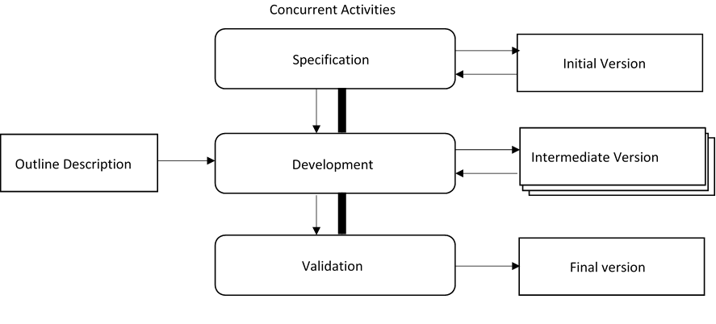**Figure 3. 1 Incremental Development Model**

There are several types of SDLC which choose to take up some number of factors based on the project for example, Requirement elicitation during the development, complexity of the system, agile process between the customers and developers, time management. These related models give the idea on the process that can be used to help user understand how different approaches are carried out during software development. They can be seen as process frameworks to create more specific software engineering processes. Below are few selected models discussed.

**3.2.1 The Waterfall Model**

It is possible to manage all projects more effectively by dividing them into a hierarchy of pieces, such as phases, stages, activities, tasks, and steps. It has a linear structure that begins with the study of the requirements and continues through design, implementation, and maintenance. This model has been thoroughly tried and evaluated, making it the most frequently acknowledged methodology for student projects. Its phases each have subphases that result in deliverables.

In system development projects, requirements are established early on before moving forward with development plans, according to Abrahamsson, Salo, Ronkainen, and Warsta (2017); the most basic representation of this is known as the "waterfall" methodology(Abrahamsson & Ronkainen, 2017), as depicted in the following figure.

**Diagram of Waterfall Model** 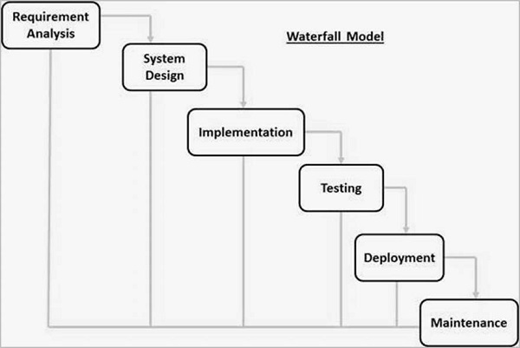

**Reasons for using Waterfall and prototype model**

* The waterfall model is used for small project and its good student project work.
* The waterfall model is developed into stages, which each phase is tested before moving to the next stage.
* Prototype model help you to design your client need.
* Phases are processed and completed one at a time.
* Since a working model of the system is displayed, the users get a better understanding of the system being developed.

**3.2.2 The Prototype Model**

The prototype model is defined as a software development process in which a prototype is designed and built several times until an acceptable prototype is achieved and approved. It also creates a base to produce the final system. It is best used in scenarios where the customer and developer do not know the necessary requirements needed. It is a repetition of trial, and error method which take place between the developer and the client.

**Approach to Chosen Methodology/Methods**

Using the Incremental Model as the SDLC, the approach to carry out each phase of the chosen methodology is define listing the set of activities carried out below and stating the chosen method used for each stage.

|  |  |
| --- | --- |
| Incremental Phases | Activities Carried out |
| Requirement Analysis | For this project, Requirements and specifications where obtained using interview and observation technique. |
| Design | In this project, some high-end functions are used to design the system in terms of objects and classes and how their interaction was carried out, explaining the structure of the Entity Relationship Diagram (ERD) and Use case activity. |
| Code | The coding of the project was conducted during this stage using Personal Home Page (PHP) for the backend development and Hypertext Markup Language (HTML) for the frontend development. |
| Test | And finally the testing phase was carried out after the system was deployed. |

**3.4 The System Design**

Before any software could be programmed decisions are needed to be made on which programming language should be used. The software been a web application, sublime text was used as the IDE and to ensure a standardized object oriented program in its entire outcome, PHP programming language was used to connect to the database which was created using XAMPP server.

This web application was developed using PHP, MYSQL Database, HTML, CSS, JAVASCRIPT (Ajax and jQuery), Bootstrap, AdminLTE Template, and some other libraries/plugins. We created this project using XAMPP Version 3.30 and does have PHP version of 8.0.7.

System Design is the process of describing the components, interfaces and architecture of a system that meet or satisfy the required specifications. It defines how the system operates and interacts with external users with the intention of describing how the system is in nature and what it does which in general captures the system’s behavior.

Employee Management

System

Administrator

Employees

The table shown below describe the category and software used in the project:

|  |  |
| --- | --- |
| CATEGORY | SOFTWARE USED |
| OPERATING SYSTEM | Windows |
| Programming Language | PHP |
| IDE | Sublime Text |
| Database | Microsoft SQL Server |

**3.5 Requirement Analysis**

Requirement analysis which is also known as requirement engineering is the process of determining the belief of a user to carry out the process of creating a new or modified application. It involves the process of studying all the task conducted to identify the needs of different stakeholders with their goals and purposes of creating systems and procedures that will achieve them in an efficient way. Therefore requirement analysis means to analyze, document, validate and manage software or system requirements.

The software requirement analysis process involves steps or phases;

1. Requirement elicitation
2. Analyzing requirements
3. Requirement modeling
4. Review and retrospective

**3.6 Requirements Specifications**

Requirement Specification is a document that captures complete description about how the system is expected to perform. It is usually signed off at the end of requirement engineering phase. It is a broad concept that could speak to any necessary function, attribute, capability and quality of a system for it to have value to customer, organization and stakeholders.

Requirement specification consist of all the necessary requirement needed to build or develop a project. It describes the software system in details and capture the goal of the system to be developed and creates a connection between the stakeholders and users to be part of the development. It consists of Functional and Non-functional Requirement.

**Functional Requirement Specifications**

Functional Requirement defines the functions of a system and its corresponding components. It deals with the services the system should deliver to do user.

**Table 1 Functional Requirement Specifications**

|  |  |  |
| --- | --- | --- |
| **Req.**  **No.** | **Description** | **Type** |
| R-01 | The application shall include a user interface. | Functional |
| R-02 | The system shall allow user to login or prompt error based on the login credentials. | Functional |
| R-03 | The system shall allow update and retrieval from the database. | Functional |
| R-04 | The system shall allow administrator to manage the user logins. | Functional |
| R-05 | The system shall allow the administrator to add or delete user credentials. | Functional |
| R-06 | The system shall allow the administrator to add, update and delete staff details. | Functional |
| R-07 | The system shall allow administrator to keep track of leave management records and generate report. | Functional |
| R-08 | The system shall allow the staff to apply for leave extension | Functional |
| R-08 | The system shall allow the staff to apply for leave | Functional |
| R-10 | The system shall automatically send SMS alerts to all staffs and administrators | Functional |

**3.6.2 Non-Functional Requirement Specifications**

Non-functional Requirement defines the requirement that specify criteria that can be used to judge the operation of a system.

**Table 2 Non-Functional Requirement Specifications**

|  |  |  |
| --- | --- | --- |
| **Req.**  **No.** | **Description** | **Type** |
| R-101 | When launched, the application shall stay running unless there is an intentional shutdown of the application or the platform. | Performance |
| R-102 | The system should be available to the users at all time. | Availability |
| R-103 | The system should be secured to avoid unwanted access. | Security |
| R-104 | The system should be reliable in such a way that it performs its tasks properly at all time without producing any ambiguous result. | Reliability |
| R-105 | The system should be able to handle the task as number of user increases. | Scalability |
|  |  |  |

**Application Architecture**

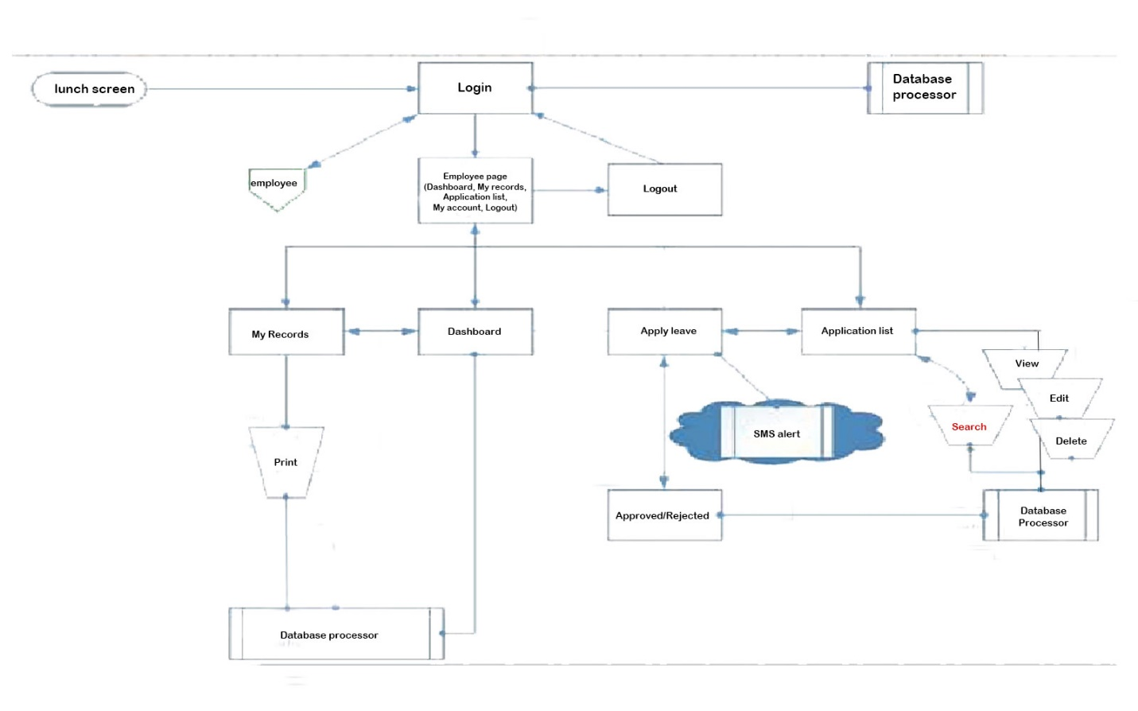 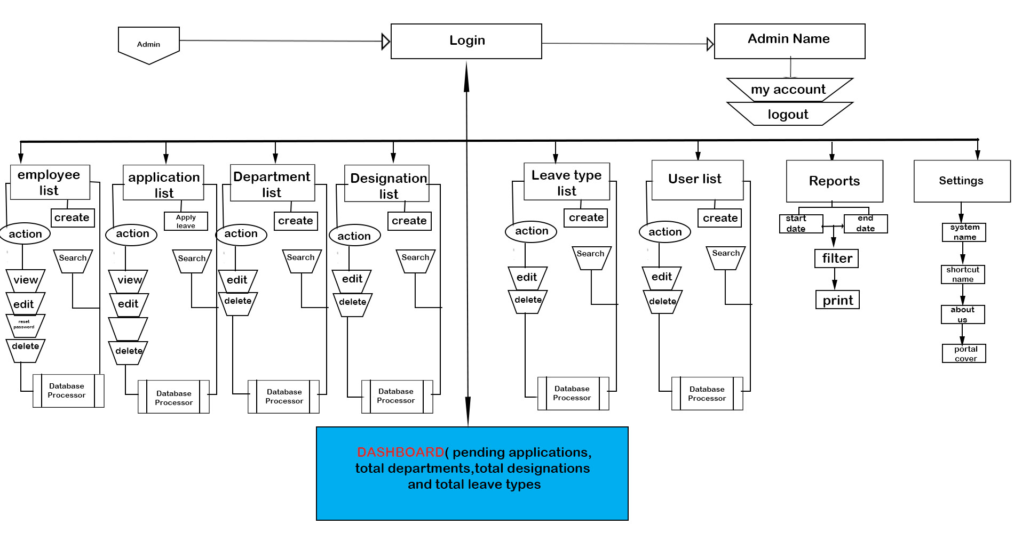

**USE CASE DIAGRAM**

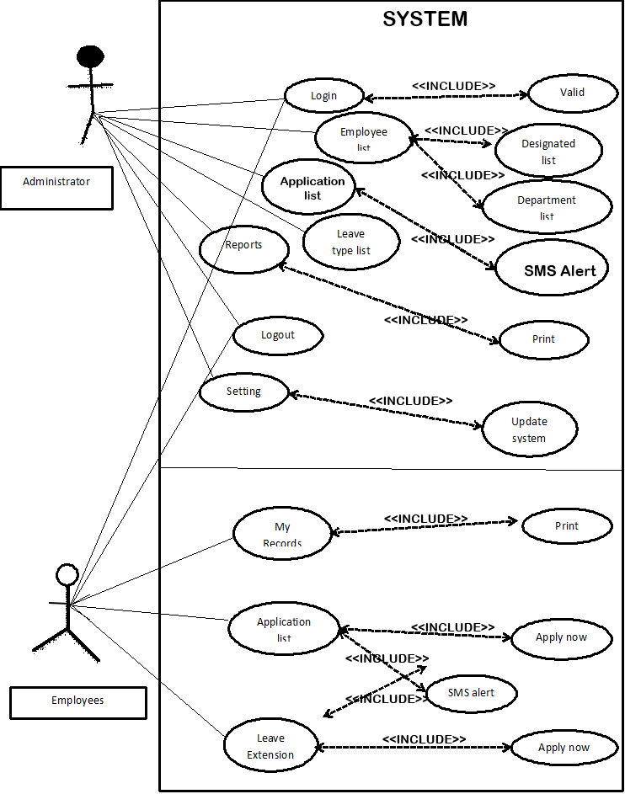

Actors:

* Administrator

Actors:

* Administrator
* Employees

Precondition:

* Administrator must be logged into the system

Post condition:

* If the user is successful, the user is logged into the system otherwise the system state is unchanged.
* If the Admin logged in successful, the Admin add, delete and view the login credentials of the entire users of the system, otherwise the system state is unchanged
* If the Admin logged in successful, the Admin will add||delete||update the employees record in the system, otherwise the system state is unchanged

Flow of Events:

Basic Flow

* The system requests that the actor enters his/her username and password.
* The actors enter username and password.
* The system validates the username and password.
* The user is logged into the system
* Admin user click on manage login credentials button.
* System respond with a manage credentials page.
* Admin add or delete or view login credentials
* System save or retrieve from the database
* System pop out successful message
* Admin clicks on Manage employee button.
* System responds with employee page.
* Admin add||delete||update and submit employee record
* System save record to the database

**Class Diagram**

age

Class Diagram

* E

EMPLOYEES

* Name
* Employee ID
* Details
* Passport

EMPLOYEES DETAILS

* Employee ID
* First Name
* Middle Name
* Last Name
* DOB
* Contact
* Address
* Department
* Designation
* Username
* Passport

ACCOUNT

* First Name
* Last Name
* Username
* Password
* passport

LEAVE TYPE

* Code
* Name
* Description
* Default Credits
* status

ADMINISTRATOR

* First Name
* Last Name
* Username
* Password
* Passport

**Entity-Relationship Diagram (ERD)**

ADMINISTRATOR

Employee IDzzzzzzzzzUserType

ACCOUNT

Name

Username

Password

Employee ID

User Type

EMPLOYEE

LEAVE

Employee ID

First Name

Middle Name

Last Name

DOB

Contact

Address

Employee ID

Employee Contact

Request Date

Leave Type

Leave FromDate

Leave ToDate

LEAVE APPROVAL

Employee ID

Employee Contact

Leave Type

Request Date

Leave Status

Remarks

GROUP MEMBER’S NAMES, INDEX NUMBERS, AND CONTACTS (GROUP 5)

|  |  |  |
| --- | --- | --- |
| NAMES | INDEX NUMBERS | CONTACTS |
| Maanyere Walter | 06191234 | 0241142063 |
| Abapori Emmanuel | 06191111 | 0240444309 |
| Yong-yel Victor | 06191297 | 0547420031 |
| Konekpieri David | 06191223 | 0547819871 |

REFERENCES

Mishal, R., Prity, S., Prachir, C., & Arhant, C. (2017). Employee Leave Management System. *International Journal of Advance Research and Innovative Ideas in Education*, *3*(05).

Hridita, A. (2018). Employee leave Management System in Metlife Bangladesh. *An Intenship Report on Meltlife*.

Manish, S., Prachi, S., & Rohil, S. S. and Shiwani, S.(2015). Leave and Payroll Management System. In *International Conference on Computing and Virtualization, Thakur, India*.

Rushitha, E., Preethi, G., Harshita, N. M., Manisha, R. R., & Veena, M. (2019). Android Leave Management System. *International Research Journal of Computer Science*, *6*(6).

Afsana, H. (2018). Employee leave management system in MetLife Bangladesh.

Alakoç Burma, Z., Amini Far, M., & Pakravan Far, M. (2017). International Journal of Education and Social Science www. ijessnet. com Vol. 1 No. 2; September 2014 85 Human Resource Management and Its Importance for Today’s Organizations Zehra Alakoç Burma, PhD, Edu. *NAJA HUMAN RESOURCES*, *8*(47), 121-137.

Abdulraheem, A. S., Zeebaree, S. R., & Abdulazeez, A. M. (2020). Design and implementation of electronic human resource management system for duhok polytechnic university. *Technology Reports of Kansai University*, *62*(4), 1407-1420.

Afsana, H. (2018). Employee leave management system in MetLife Bangladesh.

Kanchev, K. (2007). Employee Management System.

Abdulraheem, A. S., Zeebaree, S. R., & Abdulazeez, A. M. (2020). Design and implementation of electronic human resource management system for duhok polytechnic university. *Technology Reports of Kansai University*, *62*(4), 1407-1420.

Singh, P., Fartyal, H., Zubair, K. A. A., & Laddha, A. (2019). Employee Management System. *International Research Journal of Engineering and Technology (IRJET)*, *6*.

Abrahamsson, P., Salo, O., Ronkainen, J., & Warsta, J. (2017). Agile software development methods: Review and analysis. *arXiv preprint arXiv:1709.08439*.